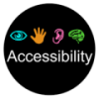

# Accessibility Guide for The Example Restaurant

[test@gmail.com](mailto:test@gmail.com%20) , [0131 472 2218,](tel:0131%20472%202218) <www.visitscotland.org>

**Contact for accessibility enquiries: Joe Bloggs**

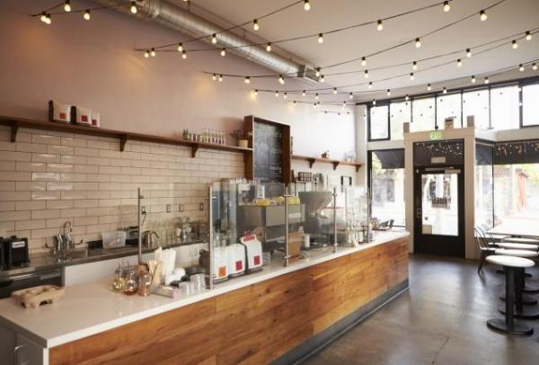

### Welcome

Family-run restaurant, offering a mix of italian dishes with good quality scottish ingredients. Whether you are looking for a quiet coffee or a two-course lunch or dinner our restaurant will always provide you with a relaxing, enjoyable atmosphere and quality dinning experience guaranteed.

We are a family-friendly restaurant catering for a variety of diets. Assistance dogs are welcome and water bowels can be provided.

Watch the video: [VisitScotland Advert 2016 | Scotland. A Spirit of its Own - Spirit Lights](https://youtu.be/otEcULXOpGc)

## At a Glance

### Level Access

* There is level access from the main entrance to:
  + Dining Table
  + Accessible Toilet
  + test

### Hearing

* The fire alarm has flashing lights.
* We have a hearing loop in the restaurant area and at reception .
* Some staff have disability awareness training.

### Visual

* Glass doors and full-height windows have contrast markings.
* The walls and the doors have high colour contrast.
* Some parts of the venue have low lighting.
* The menu is in large print.
* We have information in large print.

### General

* There is at least 1 public toilet for disabled visitors.
* Some staff have disability awareness training.

## Getting here

A Street Somewhere  
Edinburgh  
Midlothian  
Eh6 6JH

#### Travel by public transport

* You can get to The Example Restaurant by bus.
* The nearest bus is on Ocean Drive. The bus stop is 0.1 miles / 0.2 km from The Example Restaurant .
* There are a selection of buses which connect us to the city centre for example, No 22, 11, 34.

#### Travel by taxi

* You can get a taxi with Central Taxis by calling 0131 229 2468. The taxi company has a wheelchair accessible vehicle.
* You can get a taxi with City Cabs by calling 0131 228 1211. The taxi company has a wheelchair accessible vehicle.

#### Parking

* There is parking near the venue. There are accessible parking spaces. The parking is less than 50 metres from the main entrance. Parking is free.
* There is a drop-off point at the main entrance. The drop-off point has a dropped kerb.
* From the car park to the entrance, there is level access. There is a lift. The route is 1000mm wide, or more.
* The restaurant is inside a shopping centre and is accessible from the car parking via a lift. There are designated disabled parking bays in front of the shopping centre.

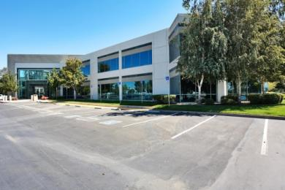  
on-street parking for disabled-badge-holders

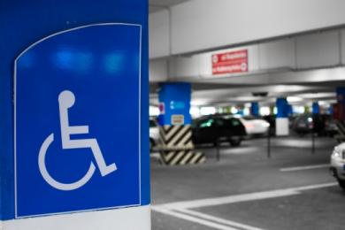  
internal-parking for disabled badge holders

## Arrival

#### Path to main entrance

* From the street to the main entrance, there is level access.
* The path is 3000mm wide, or more.

#### Main entrance

* The main entrance has level access.
* The door is 1000mm wide.
* The main door is side hung and automatic.

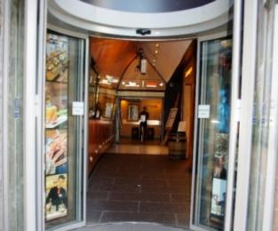  
Restaurant front door

## Getting around inside

#### Visual Impairment - General Information

* We have contrast markings on all glass doors, contrast markings on all full-height windows and high colour contrast between walls and doorframes.
* Some parts of the venue have low lighting.

#### Lift

* We have 1 lift.
* You can get a lift to all floors.

#### Lifts to all floors

* The lift door is 850mm wide.
* The lift is 1200mm wide. The lift is 1000mm deep.
* The lift buttons have raised numbers or letters.
* The lift shows the floor number, at each floor.

#### Public toilet

#### Accessible Toilet

* There is a public toilet for disabled visitors.
* From the main entrance to the public toilet, there is level access. The route is 900mm wide, or more.
* The toilet door is 880mm wide.
* The direction of transfer onto the toilet is to the left.
* There is 600mm at the side of the toilet. There is 600mm in front of the toilet. The toilet seat is 485mm high. The toilets have handrails.

#### Place to eat and drink

* From the main entrance to the dining area, there is level access. There is a lift. From the lift to dining area, the route is 900mm wide, or more. To get to a table, there are no steps.
* The menu is offered in large print.
* The route through the dining area is 800mm wide, or more.
* There is background music sometimes.
* The table and plates have high colour contrast.
* We cater for vegetarian specific diets.

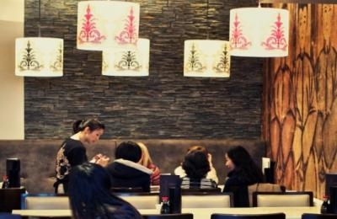  
dinning area of the restaurant

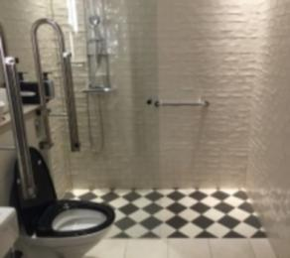

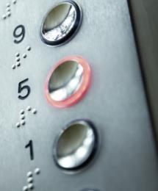  
lift buttons with braille

## Getting around outside

#### test

* From the main entrance to this area, there is level access.

## Customer care support

#### Accessibility equipment

* We have a hearing loop in the restaurant area and at reception .
* We can provide water bowls for assistance dogs on request.
* The nearest toliet area for assistance dogs is located across the road from the shopping centre, 5 metres from the main entrance.
* You can hire mobility equipment from Mobility equipment hire company by calling 0131 472 2222.

#### Emergency evacuation procedures

* We have emergency evacuation procedures for disabled visitors.
* The fire alarm has flashing lights.

#### Customer care support

* Some staff have disability awareness training.
* We have information in large print.
* We have other services for people with accessibility requirements.
* Baby changing facilities and highchairs are available.

Guide last updated: 22 May 2019